Indian Institute of Technology PATNA

ME 3101: Data Analytics and Machine Learning Tools for Engineers
PROJECT 1

Image Processing of Droplet Dynamics on a Superhydrophobic Surface

Submitted by
Name: NISHTHA SHRIVAS
Roll Number: 2403ME03
Programme: B.Tech. Mechanical Engineering

Submitted to
Prof. Rishi Raj & Prof. Atul Thakur
Academic Year: 2026–27

1. METHODOLOGY
1.1 Video and Frame Preparation
The provided video sample.mp4 was processed frame by frame using MATLAB. Each frame was extracted from the video and converted from RGB to grayscale. A total of 1016 frames were processed, with each frame having a resolution of 512 × 800 pixels. The grayscale frames were stored for further image processing and analysis.

1.2 Image Calibration
All geometric measurements were initially obtained in pixels and were subsequently converted into physical dimensions. The calibration was performed using the 2 mm scale bar provided in the reference image. The scale bar corresponds to 50 pixels, giving a calibration factor of:
Calibration factor = 2/50 = 0.04 mm/pixel
This calibration factor was used for converting pixel-based measurements such as droplet dimensions, area, and position into physical units.
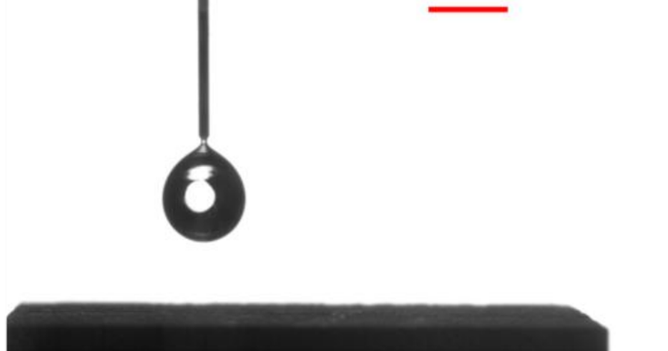
1.3 Droplet Boundary Detection
The droplet was identified based on its appearance as a dark region in the image. First, Gaussian filtering was applied to the grayscale frame to reduce noise and smooth the image. The filtered image was then converted into a binary image using thresholding. Small unwanted regions were removed from the binary image to reduce the effect of noise.
Connected-component analysis was then used to identify the separate regions in the processed image. The relevant droplet region was selected for further analysis while unwanted regions such as the nozzle and supporting structure were excluded. The detected droplet region was subsequently used to obtain its boundary and other geometric properties.

1.4 Extraction of Droplet Geometry
The detected droplet region was analysed using regionprops to obtain its geometric properties. A bounding rectangle was determined around the droplet, providing its horizontal and vertical dimensions. These dimensions were used as the droplet's horizontal (x) and vertical (y) diameters.
The number of pixels enclosed by the detected droplet region was also used to calculate its projected area. Pixel-based dimensions and area were converted into physical units using the calibration factor of 0.04 mm/pixel.

1.5 Droplet Motion and Boundary Tracking
The centroid of the detected droplet was calculated for every frame using regionprops. Its vertical position was then converted into millimetres and plotted against time to track the droplet's movement during falling, impact, and rebound.
The top-most and bottom-most positions of the droplet were obtained from the minimum and maximum row coordinates of the detected droplet boundary. These positions were tracked throughout the video to study the changes in droplet shape during impact and rebound.

1.6 Volume Estimation
The droplet volume was estimated from the measured horizontal diameter by assuming that the droplet has a spherical shape. The estimated volume was calculated for each frame and plotted against time.
This assumption provides an estimate of the volume, but the droplet is not perfectly spherical throughout the impact process. Therefore, variations in the calculated volume can also be affected by the changing shape of the droplet and the image-processing procedure.
1.7 Bounce Detection
Bounce locations were identified from the centroid trajectory. The minima of the vertical centroid-position curve were detected using findpeaks applied to the negative of the centroid-position data. The detected locations were marked on the corresponding plot and counted to estimate the total number of droplet bounces.

1.8 Key Assumptions
Keep this short because the official format specifically asks for assumptions.
The analysis assumes that the detected connected region correctly represents the droplet and that the calibration factor remains constant throughout the video. For volume estimation, the droplet is assumed to be spherical and the measured horizontal diameter is used for the calculation. The accuracy of the extracted quantities therefore depends on the quality of droplet detection and boundary identification.

2.RESULTS

2.1 Frame and Calibration Results
Parameter | Result
Number of frames | 1016
Frame size | 512 × 800 pixels
Calibration | 0.04 mm/pixel
Frame 1 droplet area | 4730 pixels
Frame 1 droplet area | 7.568 mm²

2.2 Detected Droplet Boundary
The image-processing procedure successfully identified the droplet region in Frame 1. The detected boundary follows the visible outline of the droplet, while the nozzle and other unwanted regions are excluded from the selected droplet region.
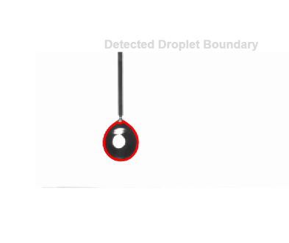

2.3 Bounding Rectangle
A bounding rectangle was obtained from the detected droplet region using the BoundingBox property of regionprops. The rectangle provides the horizontal and vertical extent of the detected droplet and forms the basis for calculating the x- and y-diameters used in the subsequent analysis.
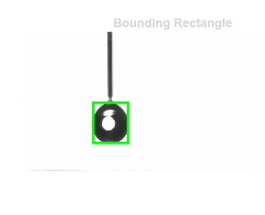
2.4 Droplet Diameter Evolution
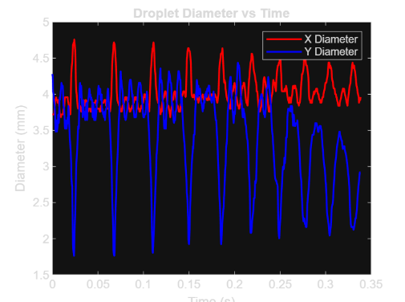
The horizontal and vertical diameters show different variations during the droplet-impact process. The x-diameter generally remains within a narrower range, while the y-diameter exhibits larger downward excursions at several stages. The difference between the two dimensions indicates that the droplet does not remain spherical throughout the impact and rebound process. The larger deviations between the two diameters correspond to periods of greater deformation.
2.5 Droplet Volume
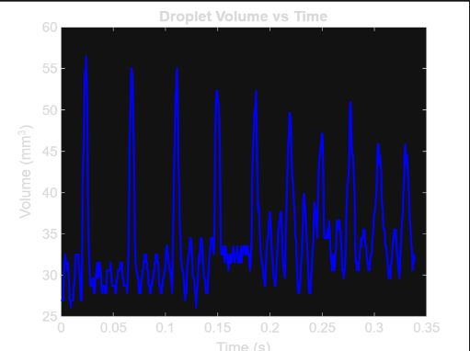
2.6 Centroid Motion
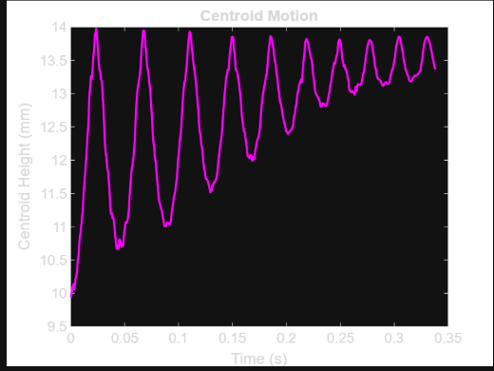
The vertical centroid position shows the motion of the droplet throughout the experiment. The repeated variations in centroid height correspond to the downward and upward motion of the droplet during successive impact and rebound events. The decreasing amplitude of the trajectory with time indicates that the rebound height becomes progressively smaller.

2.7 Top and Bottom Boundary Tracking
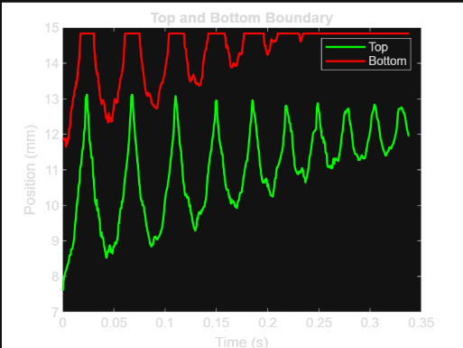
The top-most and bottom-most positions of the detected droplet boundary were tracked throughout the experiment. Both boundaries show oscillatory behaviour corresponding to the deformation and movement of the droplet. The separation between the two boundary positions changes with time, reflecting changes in the droplet's vertical extent during impact and rebound.
Bounce locations were identified from the centroid trajectory by detecting the minima in the centroid-height curve. The detected locations are marked by red circles in the plot. Using this criterion, a total of 48 bounce events were detected in the analysed video.
2.8 Bounce Detection
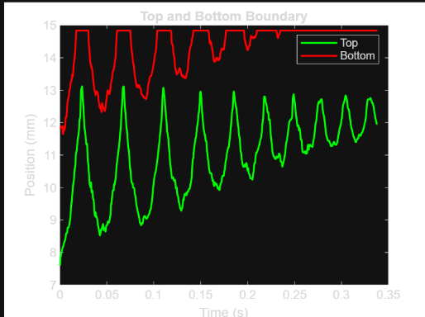
3. ANALYSIS & INTERPRETATION
3.1 Droplet Deformation
The diameter plot shows that the droplet undergoes significant deformation during repeated impact and rebound. The horizontal and vertical diameters become substantially different during the impact stages, with the vertical diameter showing large reductions while the horizontal diameter remains comparatively larger. This indicates that the droplet spreads in the horizontal direction and becomes flatter when interacting with the surface. As the droplet rebounds, the difference between the two diameters becomes smaller, indicating recovery towards a more spherical shape.
Question: During which stages do x- and y-diameters differ the most?
The largest differences occur during the stages of strong deformation associated with impact. In the diameter plot, the y-diameter decreases sharply while the x-diameter remains relatively large. These periods correspond to the droplet becoming flattened against the surface.
Question: What do these differences indicate?
A large difference between the x- and y-diameters indicates that the droplet has deviated from a spherical shape. A larger x-diameter compared with the y-diameter represents horizontal spreading and vertical compression during impact.
Question: When does the droplet recover its nearly spherical shape?
The droplet approaches a more spherical shape during the rebound stages when the x- and y-diameters become closer. The later oscillations show progressively smaller deformation, indicating that the droplet gradually settles towards a less deformed shape.

3.2 Volume Behaviour
The calculated volume should theoretically remain approximately constant because the same droplet is being tracked throughout the experiment. However, the volume obtained in this analysis is an estimate based on the measured horizontal diameter and a spherical-shape assumption. Therefore, variations in the calculated volume do not necessarily represent an actual change in the amount of water in the droplet.
Changes in the detected boundary, threshold selection, image noise, and the deformation of the droplet can affect the measured diameter and consequently the estimated volume. The spherical assumption is particularly important during impact because the droplet is visibly non-spherical at these stages.

3.3 Centroid Motion and Energy Exchange
The centroid trajectory shows repeated upward and downward motion of the droplet. The initial motion corresponds to the droplet approaching the surface, followed by a reversal in motion after impact. Subsequent oscillations represent repeated rebound events. The amplitude of these oscillations decreases with time, showing that the droplet reaches progressively lower rebound heights.
Before impact, the falling droplet has gravitational potential energy which is converted into kinetic energy as it moves towards the surface. During impact, part of this energy is temporarily stored through droplet deformation, while another part is dissipated. During rebound, some of the stored energy is converted back into the upward motion of the droplet. The decreasing rebound height indicates that the droplet loses energy over successive impacts.

3.4 Top and Bottom Boundary Behaviour
The top and bottom boundary trajectories show the change in the droplet's vertical extent during impact and rebound. The top boundary exhibits relatively larger variations, while the bottom boundary remains closer to the surface during several stages of the motion. This makes the top boundary particularly useful for observing the deformation of the droplet.
During impact, the droplet spreads over the surface and becomes flatter. The part of the droplet near the surface is constrained by contact with the surface, while the upper part undergoes larger changes as the droplet deforms and subsequently recovers its shape.
Question: Which curve more clearly indicates deformation?
The top-boundary curve shows the deformation more clearly because it undergoes larger changes in position during the spreading and recovery of the droplet.
Question: During impact, which boundary moves more rapidly?
From the plotted trajectories, the top boundary shows the larger and more rapid movement during the deformation stages. The bottom boundary is more constrained by its proximity to the surface.
Physical reason
The bottom part of the droplet interacts directly with the surface during impact, limiting its movement, while the upper part can move more freely as the droplet spreads and changes shape.

3.5 Bounce Behaviour
The bounce-detection analysis identifies repeated minima in the centroid trajectory and gives a total of 48 detected bounce locations. The rebound height decreases progressively after successive impacts, as seen from the reducing amplitude of the centroid oscillations. This indicates that the droplet does not recover all of its mechanical energy after each impact.

Question: Does rebound height increase or decrease?
The rebound height decreases after successive bounces. This occurs because part of the droplet's mechanical energy is dissipated during each interaction with the surface.

Question: What causes energy loss?
Energy can be lost through deformation of the droplet, viscous effects within the liquid, interaction between the droplet and the surface, and other dissipative effects during impact. As a result, less energy is available for the next rebound.

Question: What would happen on a hydrophilic surface?
On a hydrophilic surface, the droplet would be expected to spread more strongly and remain in contact with the surface for longer rather than showing the repeated rebound behaviour observed here. The rebound would therefore be less pronounced.

3.6 Effectiveness of the Superhydrophobic Surface
The repeated rebound of the droplet and the gradual recovery of its shape indicate strong water-repellent behaviour of the surface. The droplet is able to separate from the surface after impact and undergo multiple rebound events. The image-based measurements of diameter, centroid position and boundary movement provide quantitative evidence of the deformation and rebound behaviour.

4. METHOD EVALUATION
4.1 Accuracy of the Image-Processing Method
The image-processing method provides a simple approach for detecting and tracking the droplet throughout the video. The combination of Gaussian filtering, thresholding, removal of small regions and connected-component analysis allows the droplet to be separated from the background and used for subsequent measurements. The use of a fixed calibration factor also allows the pixel-based measurements to be converted into physical dimensions.
4.2 Sources of Error and Limitations
The accuracy of the results depends on the quality of the detected droplet boundary. Image noise, variations in brightness and contrast, and the selected threshold can cause parts of the droplet to be incorrectly included or excluded. The presence of the nozzle and supporting structure can also affect segmentation if they become connected to the detected droplet region.
Another limitation is the estimation of droplet volume. The MATLAB calculation assumes that the droplet is spherical and uses the horizontal diameter. Since the droplet becomes significantly deformed during impact, this assumption is less accurate during these stages. Therefore, the calculated volume should be treated as an estimate.
The bounce detection method also depends on the centroid trajectory. The detected minima are used as bounce locations, so the accuracy of the bounce count depends on how clearly individual rebound events appear in the centroid data.
4.3 Possible Improvements
The accuracy of the analysis could be improved by using a more adaptive segmentation procedure that can better account for changes in image intensity during the experiment. The detected boundary could also be checked against the original frames to identify segmentation errors. For volume estimation, a method that accounts for the actual deformed droplet shape rather than assuming a sphere could provide a more representative estimate. Bounce detection could also be verified using the original video frames in addition to the centroid trajectory.
5. CONCLUSIONS
Keep this section short — around 3–5 key findings, as required by the format you showed.
The image-processing approach developed in MATLAB successfully tracked the droplet throughout the provided video and enabled its geometric and kinematic behaviour to be analysed. The video consisted of 1016 frames with a resolution of 512 × 800 pixels, and image calibration gave a conversion factor of 0.04 mm/pixel.
The detected droplet boundary and bounding dimensions were used to study the deformation of the droplet during impact and rebound. The difference between the horizontal and vertical diameters showed that the droplet undergoes significant deformation during impact and gradually recovers its shape during rebound.
The centroid trajectory showed repeated upward and downward motion, with progressively decreasing rebound heights. A total of 48 bounce locations were detected using the centroid trajectory. This decreasing rebound behaviour indicates loss of mechanical energy during successive interactions with the surface.
The analysis demonstrates that image processing can be used to quantitatively study droplet impact dynamics from high-speed video. However, the accuracy of the results depends on the quality of image segmentation, boundary detection and the assumptions used for volume estimation.

6. DECLARATION
I declare that I take full responsibility for the analysis, results, MATLAB code, interpretations, and conclusions presented in this report and the accompanying presentation.
I may have consulted various resources during the development of this project. However, I have reviewed and understood the material used in my work, adapted it to my requirements, and confirm that I am able to explain and defend the methodology, code, results, and conclusions presented by me. I further confirm that the submitted work represents my own independent analysis and has not been copied from the work, code, or results of another student

Name: NISHTHA SHRIVAS
Roll Number: 2403ME03
Signature: 
Date: 1ST SEPTEMBER 2026
If the official declaration has specific wording or a particular arrangement, copy that exact wording and arrangement rather than using the above as a replacement.

7. REFERENCES

